SMALL GRANTS PROGRAM GRANT APPLICATION
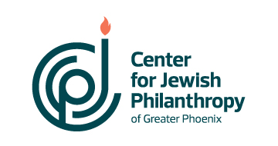
Please use a 12-point font . Combine files into ONE document and submit completed applications to Sheryl Quen, Vice President, Community Impact at squen@phoenixcjp.org.

Organization Name:
EIN or fiscal agent (if applicable):
Organization Mailing Address:

Telephone: Website:
Contact Person:
Title: Email address:

Organization Mission Statement:

Program Name:

Program Description, Activities and Goals:
Describe the program including major activities of the program, including location, and what you hope to accomplish (goals) with this program. Include answers to each component.

Program Start Date: Program End Date:
Note CJP does not fund retroactively.

Population served by the program:

Program Budget: Organization Budget:

Amount Requested from the Center for Jewish Philanthropy:

How will you fund the balance of the program?

What does success look like and how will you measure it?

If you are collaborating with other organizations, please identify them and describe their roles.

Is there anything else you would like to share about this program?

Budget

Include a project budget that lists all expenses and revenue associated with the request. Possible expense categories include salaries, professional fees, marketing, curriculum, printing, etc.

Important: Your organization’s chief executive or board chair must sign the application.

Name: Title:

Signature:

Date:

